**Angry Birds - Game Systems Info**

Interfaces 2

Main Menu 2

World Select 4

Level Select 5

Game HUD 6

Win 8

Lose 9

Pause 9

Game Objects 10

Birds 10

Pigs 16

Level Objects 18

Template Tools 20

General Settings 20

Level Tool 24

Character Tool 25

Object Tool 26

Terrain Tool 28

Game References 30

Angry Birds Games 30

Games Similar to Angry Birds 30

# Interfaces

## Main Menu

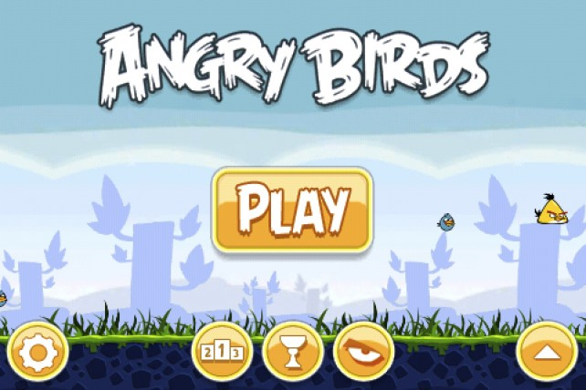

* Animated background – displays the name of the game, the current world background that the player has last played is slowly scrolling, as well as the birds flying across the screen
* Buttons on Main Menu
  + **Play** – a button that opens up the World Select screen
  + **Options** – a button that slides open a rectangle box with 2 buttons
    - **Credits button** – clicking/touching this will hide the menu buttons and title, the background will continue to scroll and the birds will continue to fly across the screen, then text style credits will begin to scroll up from the bottom. The credits will continue to loop until the player hits the Back button in the bottom left of the screen
    - **Sound on/off button** – sound is on by default, if the user clicks it then the button will switch to off. The sound will gradually fade out or in when turning the sound on or off.
  + **Leaderboards** – button that will open Apple’s GameCenter for the Leaderboards
  + **Achievements** – button the will open Apple’s GameCenter for the Achievements
  + **Mighty Eagle** (in-app purchase) – dims the screen with text about the Mighty Eagle, a button to an external video, and a purchase button. Clicking the button will bring you to the Apple ID login, after login in you will need to confirm the purchase, then you will be brought back to the Main Menu and the button is gone

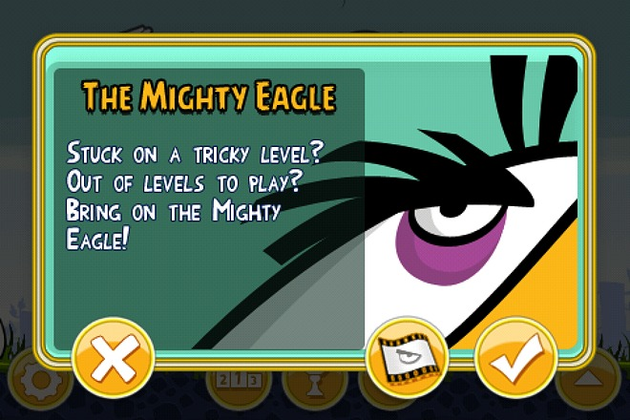

* + **Social buttons** – a button that slides open a rectangle box with 4 buttons
    - **Facebook** – button to open Facebook and display Angry Birds fan page
    - **Twitter** – button to open Twitter and display Angry Birds Twitter feed
    - **Crystal** – button to open Crystal gaming hub
    - **Video** – button to open a YouTube with angry birds’ video
    - **Mighty Eagle Video** – once the Mighty Eagle in-app purchase has been purchased, the video link is moved into the Social buttons box

## World Select

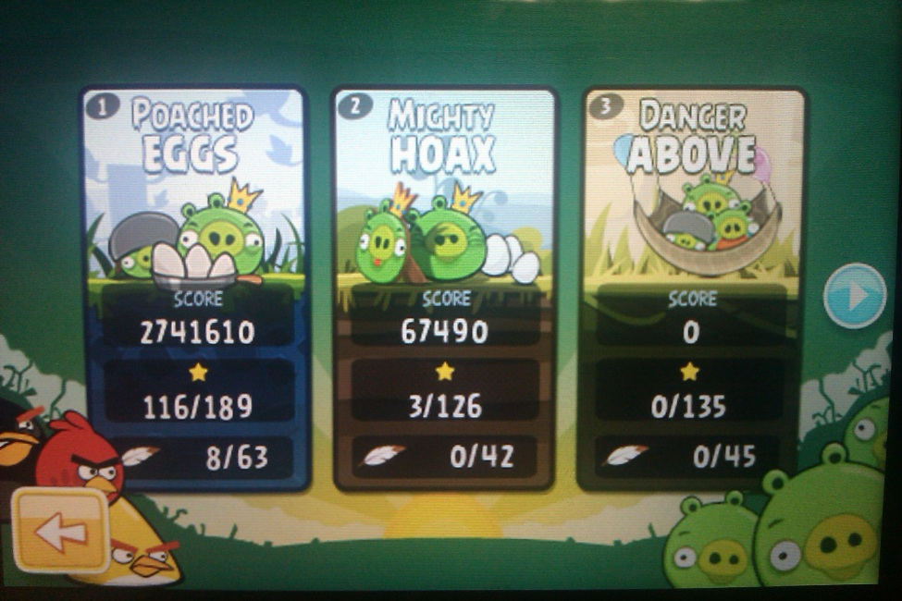

* Static Background image
* 3 buttons available to navigate
  + **Forward** – arrow button will scroll to the right through the available worlds
  + **Back** – arrow button will scroll to the left through the available worlds
  + **Home** – button which looks like another back arrow in the bottom left corner to go back to the Main Menu
* Images of each World of levels are large button icons, click/touching one will open the Level Select screen for that World
* Click and drag with a mouse or touch and drag on iOS to scroll through the available Worlds instead of using the Forward and Back arrow buttons
* When the next World image is dragged within 10% of the view, the images slide and snap to show the new currently available Worlds
* Each World image will show the stats for the World. The stats include the players current score added up from all the levels, how many Stars the player has earned out of the amount available to earn, and how many 100% Feathers the player has earned out of the amount available to earn by using the Mighty Eagle in-app purchase

## Level Select

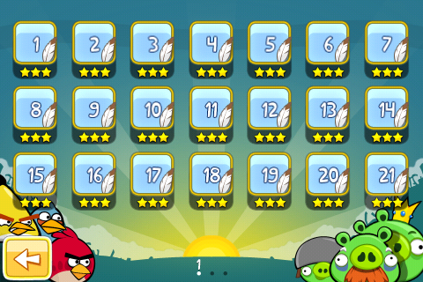

* Static Background image, different from the World Select background image
  + Background gradient changes color to match the color of the level icons
* Only 1 button available for navigation
  + **Back** – arrow button that will bring the user back to the World Select screen
* Levels have a lock icon when not available
  + Users must pass/finish the prior level before the next level is unlocked
* If more than 21 levels on the screen, a new page of levels is created
  + 3 rows and 7 columns
* Indicator at the bottom tell the user what page of levels is currently being displayed with the circle lite white and a number above it, then the other pages are a black circle next to it in the order the pages are available
* Click and drag with a mouse or touch and drag on iOS devices to scroll through the pages of levels that are available to the user
* When the next page is dragged 5% (about the border of the next pages level icon) onto the current page, that levels page snaps to the center of the screen to be available to the user
* At the bottom of each Level icon is how many Stars the player has earned for that level, it ranges from 1 to 3 Stars
* If a player has earned 100% for the level by using the Mighty Eagle, a feather image is placed on the level icon next to the level number
* If a level has been completed by only using the Mighty Eagle, then the level icon will have the image of the Mighty Eagle on it and no number or Stars

# Metagame

* Each World contains a different amount of levels based on the structure of the World’s theme
  + The Beginning World (Poached Eggs) introduces the player to all the basic birds and enemy Pigs; it also gives them a sense of what to expect in playing the game further and should contain the largest amount of levels
  + Special Event Worlds should contain a small amount of levels to give the player an quick enjoyable experience for the event (Example: Birthday Party)
  + All other levels should contain about the same amount of levels that will keep the player entertained with the theme
  + When a new bird is introduced for the first time, the following levels are designed to help the user understand the strengths and weaknesses around the new bird
    - After about 5 levels of the new bird, birds the user has already has experience with will slowly be introduced with the new bird
  + The player must be able to easily get a 2 Stars based on basic strategy when playing a level
  + For more advanced levels, the player must find weak points in structures or find a chain reaction that will achieve a 3 Star rating for the level
* The goal of each level is for the player to destroy all the pigs in the level and achieve a 3 Star rating
  + By finishing the level, the player will get a 1 Star rating
  + If the player gets a certain amount of points based on the amount of objects in the level, the player will get a 2 Star rating
  + If the player finds the weak point in the structure or the chain reaction with 1 or 2 birds, then that player will get a 3 Star rating
  + If the player activates the Mighty Eagle in the level, they will receive a feather on the level icon if they get a 100% destruction score based on the amount of objects that are destroyed in the level
* Levels will start out with basic enemy Pigs, such as the small and medium. The helmet pig will take place of the small pig in levels once the player has finished the first page of levels in World 1 (Poached Eggs)
* The last level on each page for the World will introduce a new enemy Pig until all enemy pigs have been introduced
* Once a player has finished a page of levels, the Next button will change to a Cut Scene button and help drive the storyline of the game

## Game HUD

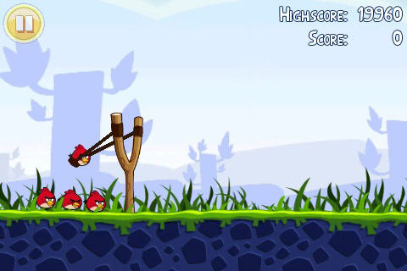

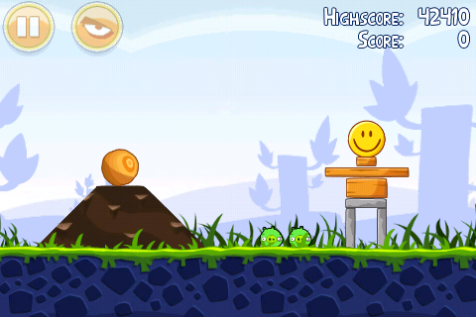

* Only 2 buttons are available on the gameplay screen, Pause and the Mighty Eagle button
  + Pause button will open up the Pause Menu (see the Pause section for specifics)
  + 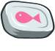When the user touches the Mighty Eagle button, all the birds disappear and in the slingshot will be a can of tuna. Once the can of tuna is in the slingshot, the player must launch the tuna over to where they want the Mighty Eagle to land in the level
* The background is a parallax style background consisting of 3 images (foreground, background, and sky) that slide at different speeds when the player moves the camera around or a bird flies across the screen
* On the top right of the screen is the players current score and will update every time an object is destroyed. If the player has already finished the level, their high score will be displayed above the current score
  + If the player has activated the Mighty Eagle in the level, then the score turns into the players’ best percentage they have earned on that level. If no score has been earned yet, then the default will be 0%
* Characters line up behind or in front of the launcher based on the sequence they will be used
* Launcher follows finger or mouse pointer
  + Max expansion of the band in the slingshot is 80% of the height of the launcher (iOS ~85% band extension and Chrome is 75% band extension)
  + If finger/mouse pointer is under the launcher the sling will lay in the groove of the slingshot
  + Different lengths of expansion determine how far and the speed/velocity that the character will fly in the air
* When a bird is launched, a trial of cloud puffs is left behind to help the player determine their next launch
  + Once the player has launched their next bird, the previous trail disappears and is replaced with the trail from the new bird
* Regardless of size, a direct hit from any bird will result in destruction of the enemy pig
* If an pig falls from any distance, the enemy will disappear no matter what its size or mass is
* If a pig is hit with 1-3 objects that are listed in the Level Objects section, depending on the objects mass they pig will disappear
* The objects in the level (glass, wood, and stone blocks that make up the level) each have 4 different sprites that it switches though depending on the amount of damage done to the object
* If the player has used the Mighty Eagle to finish a level they have not completed with the standard set of birds, the icon will grey out and there will be a cool down timer of 1 hour before the player can use the Mighty Eagle again. After the cool down timer has finished, the level icon will change back to the original number. The player will be able to use the Mighty Eagle on all the other levels they have completed while there is a cool down timer for the next level.
* There are 8 birds each with their own special ability and weight/mass to destroy objects of different masses
* Once a bird is in the air, user can touch the screen or click with a mouse to activate the birds with a special ability
  + Special Abilities can only be used once, some effects must be activated before the bird hits an object
  + Click/touch anywhere on the screen to activate the birds ability

## Win

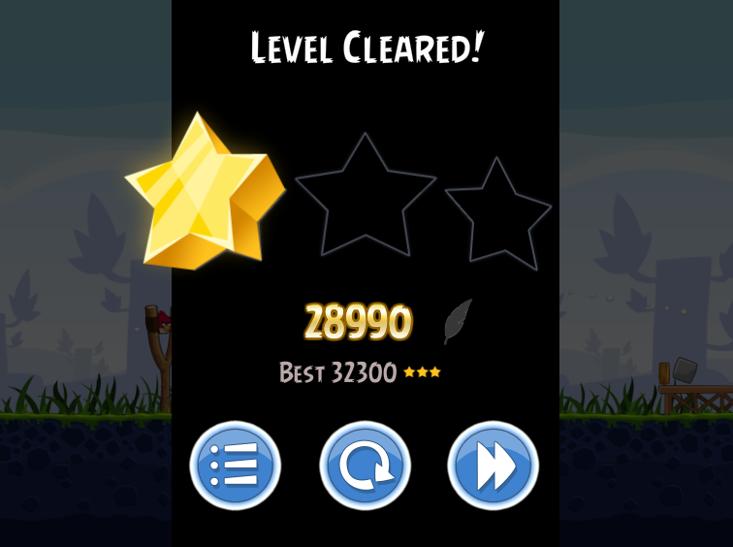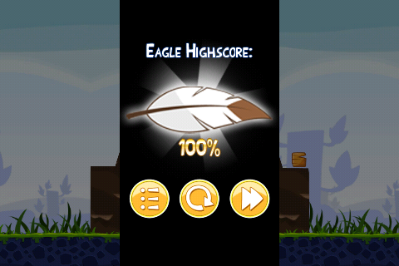

* Screen displays once the last enemy and the used characters have disappeared
* Displays the score the player earned for the level from all the blocks destroyed, enemies defeated, and characters not used
  + If the user is replaying the level after completing it, their Best or High score for the level will be displayed below the current score
* Displays how many Stars the player received based on their score
* 3 buttons are available to the player
  + **Replay** – restarts the level, everything is back in its original place
  + **Level Select** – opens up the Level Select Screen that the user was on last
  + **Next Level** – opens up the next level in the sequence unless it’s the last level on the level select page, if it’s the last level then this button is replaced with a movie button
* If the player switched to the Mighty Eagle during gameplay, then the Stars and Score are replaced with a Feather image that fills up from 0 – 100% on how much was destroyed

## Lose

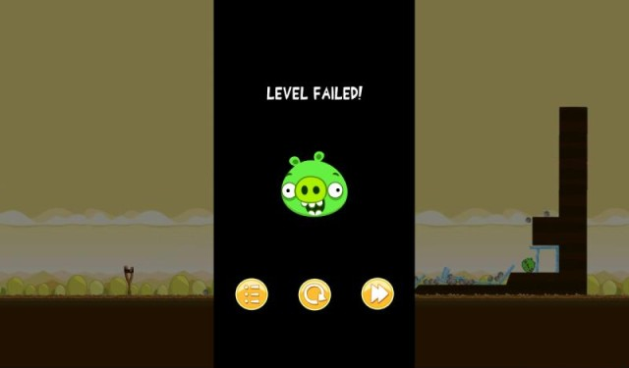

* Screen displays once the last used character has disappeared
* Lets the user know they failed the level with text and an image
* 3 buttons are available
  + **Replay** – restarts the level, everything is back in its original place
  + **Level Select** – opens up the Level Select Screen that the user was on last
  + **Mighty Eagle** – restarts the level, everything is back in its original place, but the birds have been switched with a can of tuna. If the player has not purchased the Mighty Eagle, the in-app purchase page will be displayed so they can purchase it before they restart the level with the can of tuna
    - If the level is being replayed, then the Mighty Eagle button will be replaced with a Next Level button

## Pause

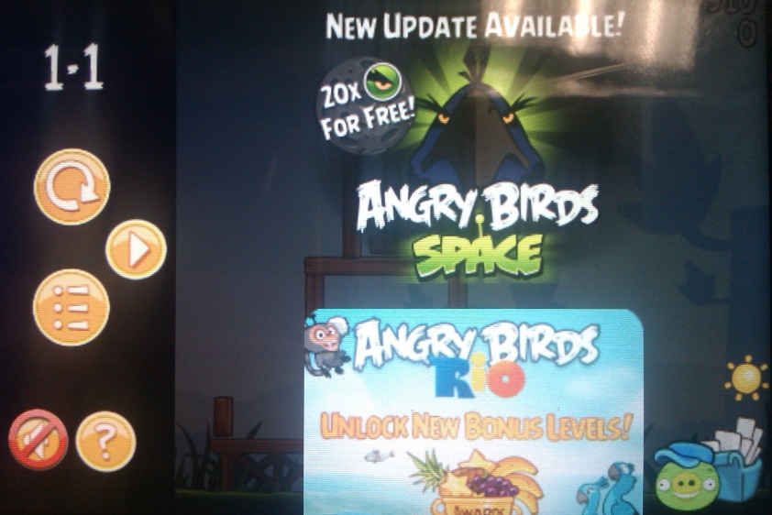

* Blacks out the scene and everything is stopped, even if a bird was in mid-flight
* World and Level number are displayed
* 5 buttons are available
  + **Restart Level button** – restarts the level, everything is back in its original place
  + **Resume button** – continues gameplay exactly where the game was when the player touched the pause button
  + **Level Select button** – stops the level and opens up the Level Select Screen that the user was on last
  + **Sound on/off button** – will have the choice made by the user from the Main Menu, sound is on by default otherwise, if the user clicks it then the button will switch to off. The sound will gradually fade out or in when turning the sound on or off.
  + **Help button** – displays the use of each bird and the basics of how to use the slingshot
  + **Ads on/off button** – this button is off to the side next to the ads and is not clear that it is a button. By default the ads are turned on, and if you touch the button the ads will disappear and the button image will change

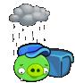

* Ads
  + Displays links to app store to other angry birds games
  + Player can scroll up and down through the available ads
  + Before the ads are displayed a connection image is shown so the player knows that device is trying to connect to the internet to get the latest ads
    - If no internet connection is available then an image will be displayed letting the user know that there is no connection

# Game Objects

## Birds

|  |  |  |
| --- | --- | --- |
| Red Bird | | |
|  |  |  |
| Mass = 2  Ability = None   * This one of the only 2 bird that does not have a special ability, the other bird is the Big Brother Bird (Terence) * When the player clicks/touches the screen, the Red Bird will change animation/sprite and make a sound | | |

|  |  |  |  |
| --- | --- | --- | --- |
| Blue Bird | | | |
|  |  |  |  |
| Mass = 1  Ability = Multiply   * Turns 1 bird into 3 * Each bird will use the same sprite/animation for in-air once separated * The middle bird stays at the same angle that the original bird was launched at * The 2 new birds branch off at ~+/-15 degrees from the middle bird * Once the ability has been activated, all birds will have the same velocity of the original bird | | | |

|  |  |  |  |
| --- | --- | --- | --- |
| Yellow Bird | | | |
|  |  |  |  |
| Mass = 2 (before ability has been activated)  Mass = 4 (when ability has been activated)  Ability = Propel   * Only when in air, click/touch to double the max speed/velocity * When the ability is activated the bird will stay at the current angle when the ability was activated   + Example: player clicks/touches the screen when the bird is at a -30 degree angle from the ground, the bird will increase his speed and stay at -30 degrees until he hits an object * When the ability is activated, the birds mass is also double, allowing it to break/destroy more objects than normal * In Space version, where the player touches the screen is where the character will propel to | | | |

|  |  |  |  |
| --- | --- | --- | --- |
| Black Bomb Bird | | | |
|  |  |  |  |
| Mass = 4  Ability = Explode   * Explodes after 3 seconds of hitting an object * Click/touch to explode early * Explosion is an area of effect * Destroys all objects within 2 times the birds size | | | |

|  |  |  |
| --- | --- | --- |
| White Bomb Bird | | |
|  |  |  |
| Mass = 3 (when ability has not been used)  Mass = 1 (when ability has been used)  Ability = Egg Bomb   * Only when in air, click/touch to drop a bomb where the bird is currently flying over * Birds mass changes after egg bomb is dropped * Bomb drops from bird and falls with gravity * Destroys all objects within an area the original size of the bird | | |

|  |  |  |  |
| --- | --- | --- | --- |
| Boomerang Bird | | | |
|  |  |  |  |
| Mass = 2  Ability = Boomerang   * When the bird launches, he's constantly spinning. This spinning plays into its special ability to change its course in midair to return to his point of origin. When the player clicks/touch the screen the Boomerang Bird will open its large beak wide (changing its animation/sprite), making it act like a boomerang and causing it to turn around and start flying back to his point of origin. * This ability to fly backwards allows it to strike areas that the other birds can't reach. * The longer a player waits to activate the boomerang feature, the lower the hit will be. | | | |

|  |  |  |
| --- | --- | --- |
| Big Brother Bird (Terence) | | |
|  |  |  |
| Mass = 6  Ability = None   * This one of the only 2 bird that does not have a special ability * When the player clicks/touches the screen, the Red Bird will change animation/sprite and make a sound | | |

|  |  |  |
| --- | --- | --- |
| Orange Bird | | |
|  |  |  |
| Mass = 2 (when ability has not been used)  Mass = 6 (when ability has been used)  Ability = Expand   * Expands to 10 times original size after hitting an object * Click/touch to activate early * When the bird expands, all objects that are within the area after it expands are destroyed no matter what their mass/strength is | | |

|  |  |  |  |
| --- | --- | --- | --- |
| Ice Bird (Space version only) | | | |
|  |  |  |  |
| Mass = 1  Ability = Freeze   * Freezes objects within 4x the size of the bird after hitting an object * Click/touch to activate early * All object that are frozen has the strength of the glass objects | | | |

|  |  |  |
| --- | --- | --- |
| Mighty Eagle (in-app purchase) | | |
|  |  |  |
| Mass = 10  Ability = Boomerang   * Removes all the characters and switches it with a can of tuna * Destroys everything it hits * All pigs are destroyed even if they are not hit by the Mighty Eagle * Point Score switches to percentage of objects destroyed (see Win section for info and image reference) * Mighty Eagle in action | | |

## Pigs

* There are 6 different enemy pigs that vary in size, weight/mass, and a different tolerance for how many objects can fall or roll on them before they disappear
* When a bird directly hits a pig, the pig will disappear no matter what its size or mass is

|  |  |
| --- | --- |
| Baby Pig (Small) | |
|  |  |
| Mass = 1   * Will disappear from almost any type and amount of damage except if a Mass 1 object rolls on the pig, then he will change to the damaged animation/sprite | |

|  |  |
| --- | --- |
| Medium Pig | |
|  |  |
| Mass = 2 | |

|  |  |
| --- | --- |
| Large Pig | |
|  |  |
| Mass = 3 | |

|  |  |
| --- | --- |
| Helmet Pig | |
|  |  |
| Mass = 4 | |

|  |  |
| --- | --- |
| Mustache Pig | |
|  |  |
| Mass = 5 | |

|  |  |
| --- | --- |
| King Pig | |
|  |  |
| Mass = 6 | |

|  |  |
| --- | --- |
| Fat Pig (Space version only) | |
|  |  |
| Mass = 8 | |

## Level Objects

* The levels are filled with blocks of different masses/strengths
* Depending on how a bird hits an object or 2+ objects collide, the sprite will change to make the object look damaged

|  |  |
| --- | --- |
| Glass Blocks | |
|  | * **Weak** * Mass = 1 * **Damage**   + Takes 1 hit to break with any characters weight * Birds that can destroy it   + Red Bird   + Blue Bird   + Yellow Bird   + Black Bomb Bird   + White Bomb Bird   + Boomerang Bird   + Big Brother Bird   + Orange Bird   + Mighty Eagle |

|  |  |
| --- | --- |
| Wood Blocks | |
|  | * **Average** * Mass = 2 * **Damage**   + Takes 1 hits to break with Mass 3 characters weight * Takes 2 hits to break with Mass 1 characters weight * Birds that can destroy it   + Red Bird   + Yellow Bird   + Black Bomb Bird   + White Bomb Bird   + Boomerang Bird   + Big Brother Bird   + Orange Bird   + Mighty Eagle * Birds that cannot easily destroy it   + Blue Bird |

|  |  |
| --- | --- |
| Stone Blocks | |
|  | * **Strong** * Mass = 3 * **Damage**   + Takes 3 hits to break with Mass 3 characters weight * Takes 6 hits to break with Mass 1 characters weight * Birds that can destroy it   + Black Bomb Bird   + White Bomb Bird   + Big Brother Bird   + Orange Bird   + Mighty Eagle * Birds that cannot easily destroy it   + Red Bird   + Blue Bird   + Yellow Bird   + Boomerang Bird |

|  |  |
| --- | --- |
| Other Objects | |
|  | * **Weak** * Mass = 1   + These objects have the same consistency as glass, but contain only 1 sprite image for the game (Example: if a glass block gets hit and is changes to a damage sprite, the Other Objects use the same image for a damaged state). Once the object has disappeared, the player receives points for the destruction * **Damage**   + Takes 1 hit to break with any characters weight * Some objects give the player extra points for their end level score * Stops a birds movement * List of Objects in Angry Birds Rio   + Cardboard   + Crate   + Walls   + Metal armor Crates   + Glass/Ice   + Stone   + TNT Crate   + Rubber Ring   + Grass   + Vines   + Beach ball   + Umbrella   + Sandstone   + Rock   + Balloons   + String   + Feathers |

# Theme Ideas:

* Mice vs. Cats
* Spirit Orbs vs. Demon Orbs
* Humans vs. Vampires
* Geeks vs. Nerds
* Gnomes vs. Plants
* Gnomes vs. Gnomes
* Nature vs. Technology
* Light vs. Shadow
* Daredevils vs. Protesters
* Pirates vs. East India Company
* Snowmen vs. the Heat

# Template Tools

General Settings – General Tab  
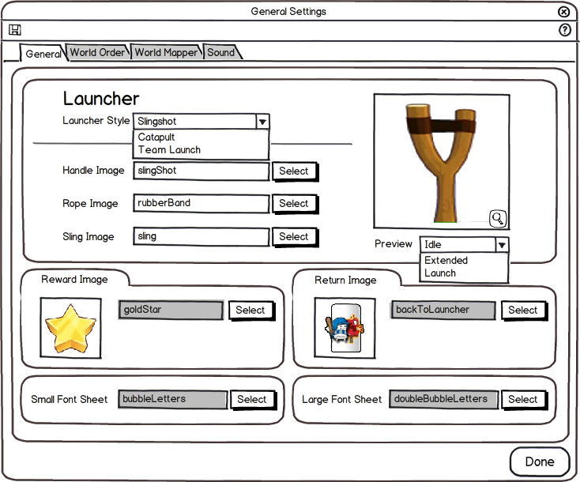

* The user can change the launcher to 3 different styles, each with its own style of launching the characters/projectiles
  + Slingshot (Angry Birds)
    - The player will drag the sling back when they click/touch the slingshot
    - It sling will extend to a max of 80% of the slingshots height
    - The user will need to provide 3 images
      * Handle
      * Rope
      * Sling
  + Catapult (Crush the Castle)
    - The player will touch the catapult once to swing, touch again to launch the projectile/character
      * If the player fails to launch the projectile/character the catapult will launch it into the ground and it will be a failed shot
    - The user will need to provide 3 images
      * Main Body
      * Catapult Arm
      * Sling
  + Team Launch (Coco Loco)
    - The player will drag their finger or mouse pointer (similar to Angry Birds Slingshot) from the team then away from them in the opposite direction they wish to launch
    - A line in front of the team will appear to help the player guide their launch
    - The arrow will grow/shrink depending on how far away the player has dragged their mouse pointer/finger
    - The arrow will extend double the size of the teammate launcher
    - The user will need to provide 4 images
      * The Teammate (the launcher) Idle
      * The Teammate Launched
      * Directional Arrow Head
      * Arrow Body
* Users can also set the Reward Image that will be displayed when a player completes a level
  + The amount of Reward Images (1 – 3) that will be displayed is determined in the Level Tool
* The Return Image is optional to the user, this will only appear when the player has launched a character, when the player clicks/touches the Return Image, the screen will go back to the launcher in the level

General Settings – World Order Tab  
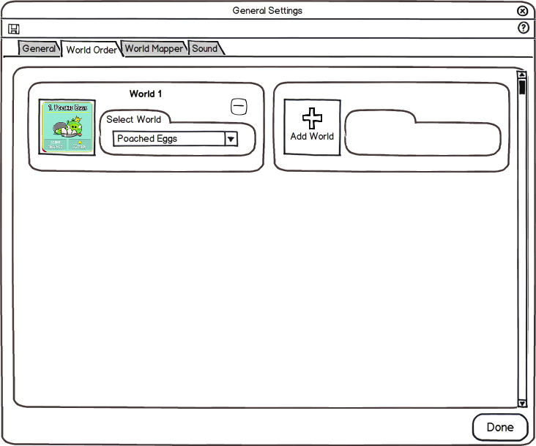

* Worlds need to be created in the World Mapper tab before they appear in the drop down on the World Order tab
* Users will set the World Order list by using the drop downs and clicking on the Add World button to add another World of levels to the World Select Screen
* When a user clicks on the Add World button, the next available World that has not been used will be the default level available in the drop down
  + Example: In the World Mapper tab the user has set Worlds 1, 2, and 3. In the World Order tab, the user has set World 1 as the first world, and World 3 as the second world in the World Order. So when the user clicks Add World, World 2 will be listed in the drop down.

General Settings – World Mapper Tab  
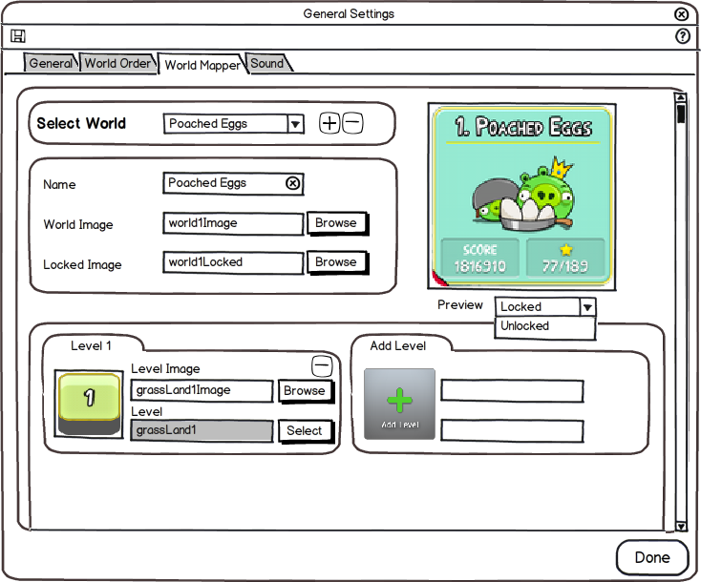

* Users can add or remove Worlds from the list
  + This will remove all the settings from that World and the drop down will go to the next available World in the list
  + This will NOT delete or remove any of the Levels associated with that World
* The user can set the name, image for when the world is available, and an image for when the world is unavailable
* When the user clicks on the Add Level button, the user will be brought to the Asset Library to choose a level that has been created
* The user may also change the level image that will appear in the Level Select screen

Level Tool  
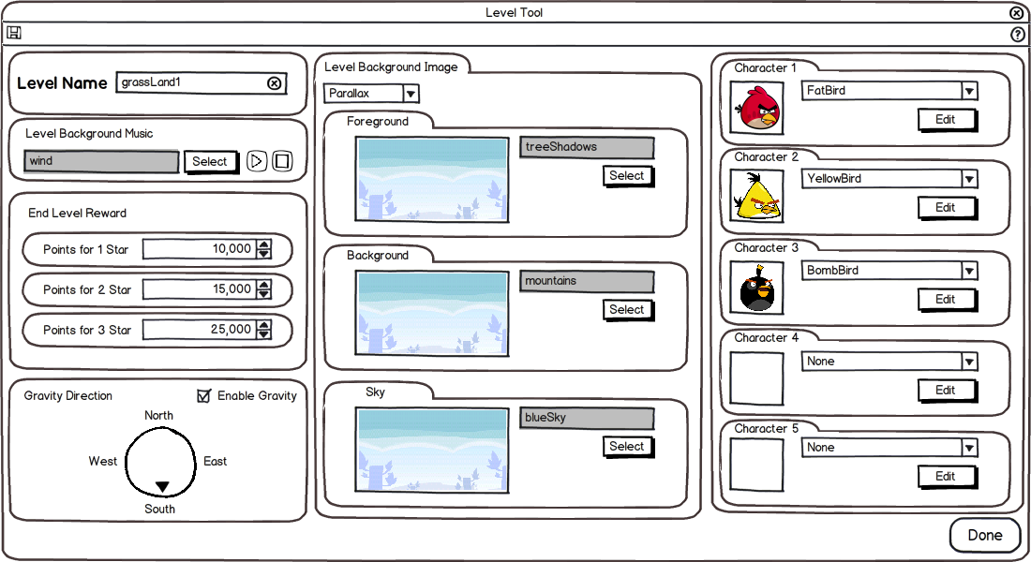

* The user can set the name of the currently opened level
  + This will be used in the Asset Library and the General Settings – World Mapper tab
* The user may set the number of points needed to earn a different amount of the End Level Reward image
  + The image for the End Game Reward is set in the General Settings tool
  + This is set on a per level basis
* Gravity can be set to 1 of 5 styles, the 4 compass directions (North, East, South, and West) or for there to be no gravity at all
* Two different type of backgrounds can be set for the level, static and parallax
  + The user will be able to select which style of background they want to use with the drop down
  + Static – a static background will be a single image that will fill the entire background
  + Parallax – will consist of 3 separate images, foreground, background, and the sky, each will move at different speeds depending on the size of the level
* Each level will have up to 5 character slots that can be filled with characters available in the drop down that have been created in the Character tool

Character Tool  
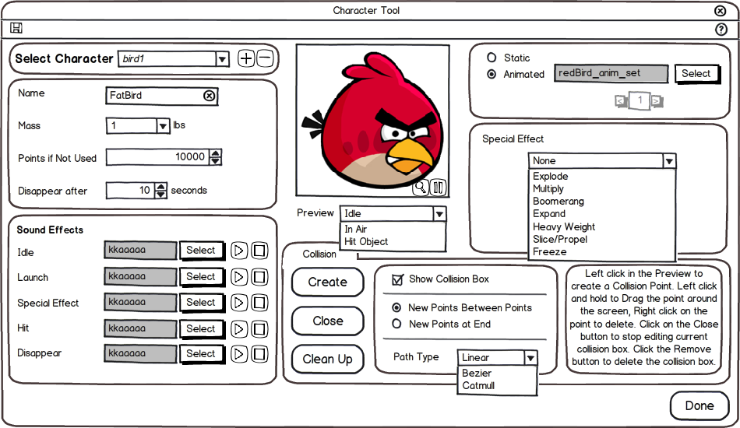

* The user can add a name to the Character for reference in the drop down for this tool and the Level tool
* The user can set the mass of the Character (1 – 10) with the drop down
* The user can set how many points the player will earn when the Character is not used during a level
* The user can set how many seconds after the Character has hit an object will it take to disappear
* In the Sound Effects section the user will be able to set 5 different sounds
  + Idle – this is for when the Character is sitting next to the launcher
  + Launch – this sound goes off right after the Character is launched
  + Special Effect – this sound goes off when the special effect is activated
  + Hit – when the Character hits an object or terrain
  + Disappear – when the Character disappears after the amount of time that was set in the Disappear After setting
* The user will be able to directly create the collision areas on the level with tools similar to those in iT2D
  + All Character will start with no collision box until the Create button is clicked, once clicked then a basic box will appear in the center of the Preview window
  + Once the collision has been added, the Create button will switch to a Remove button to remove the collision box that has been added to the Character
  + The remaining tools will only be available after the user has added a collision box
  + The Close button will stop all editing of the collision box
  + The Clean Up button will remove any collision points that create a concave hull
  + The user can hide the collision box in the scene by unchecking the Show Collision Box
  + All collision points will have a number on them which will help the user on what the 2 radio options allow
    - When the radio New Points Between Points is selected, if the user left clicks in a space that is between any 2 points, a new collision point is created
    - When the radio New Points at End is selected, if the user left clicks anywhere, a new collision point will be created between the last 2 collision points in the sequence
  + Path Type drop down will allow the user to change the curvature of the path based on the selection of the drop down
    - Linear – The default path type. Creates sharp edges with no curves
    - Bezier – The edges of a Bezier path can have their curves individually edited. Simply drag the white handles next to each curve. Smaller curves will be sharper with a more direct movement, while wide curves will have a slower, smoother movement
    - Catmull – The edges of a Catmull path is determined dynamically by the placement of each node in the path

Object Tool  
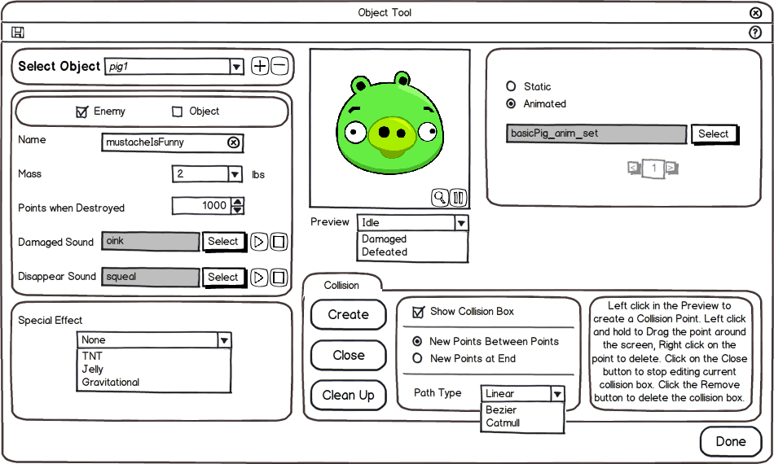

* The user must set if the Object being created is an Enemy or an Object
  + If the Enemy checkbox is selected, then this will allow the enemy to be destroyed if directly hit by a character, and it will appear in the Terrain tool once the user has saved
  + If the Object checkbox is selected, then once the user has saved the object, it will appear in the Terrain tool
* The user can add a name to the object for reference in the drop down or when they hover their mouse over the object in the Terrain Tool
* The user can set the mass of the object (1 – 10) with the drop down
* The user can set how many points the player will earn when the object is destroyed
* The user can set 2 different sounds for the object
  + Damaged Sound – for when the object is hit be another object or character
  + Disappear Sound – for when the object disappears from the scene and the player receives points for destroying the object
* A Special Effect may be added to the object
  + TNT – Will cause the object to explode when any object of any mass hits this object, this will destroy all objects within the specified world units no matter what the objects mass is set at
  + Jelly – Will allow other objects to pass through the jelly object, depending on the thickness set in the Jelly effects setting determines how far other objects will go through it
  + Gravitational – Will make the object have a gravitational field around it, this will have other objects, enemies, or character drawn towards it once they enter the gravitational field
* The user will be able to directly create the collision areas on the level with tools similar to those in iT2D
  + All Character will start with no collision box until the Create button is clicked, once clicked then a basic box will appear in the center of the Preview window
  + Once the collision has been added, the Create button will switch to a Remove button to remove the collision box that has been added to the Character
  + The remaining tools will only be available after the user has added a collision box
  + The Close button will stop all editing of the collision box
  + The Clean Up button will remove any collision points that create a concave hull
  + The user can hide the collision box in the scene by unchecking the Show Collision Box
  + All collision points will have a number on them which will help the user on what the 2 radio options allow
    - When the radio New Points Between Points is selected, if the user left clicks in a space that is between any 2 points, a new collision point is created
    - When the radio New Points at End is selected, if the user left clicks anywhere, a new collision point will be created between the last 2 collision points in the sequence
  + Path Type drop down will allow the user to change the curvature of the path based on the selection of the drop down
    - Linear – The default path type. Creates sharp edges with no curves
    - Bezier – The edges of a Bezier path can have their curves individually edited. Simply drag the white handles next to each curve. Smaller curves will be sharper with a more direct movement, while wide curves will have a slower, smoother movement
    - Catmull – The edges of a Catmull path is determined dynamically by the placement of each node in the path

Terrain Tool  
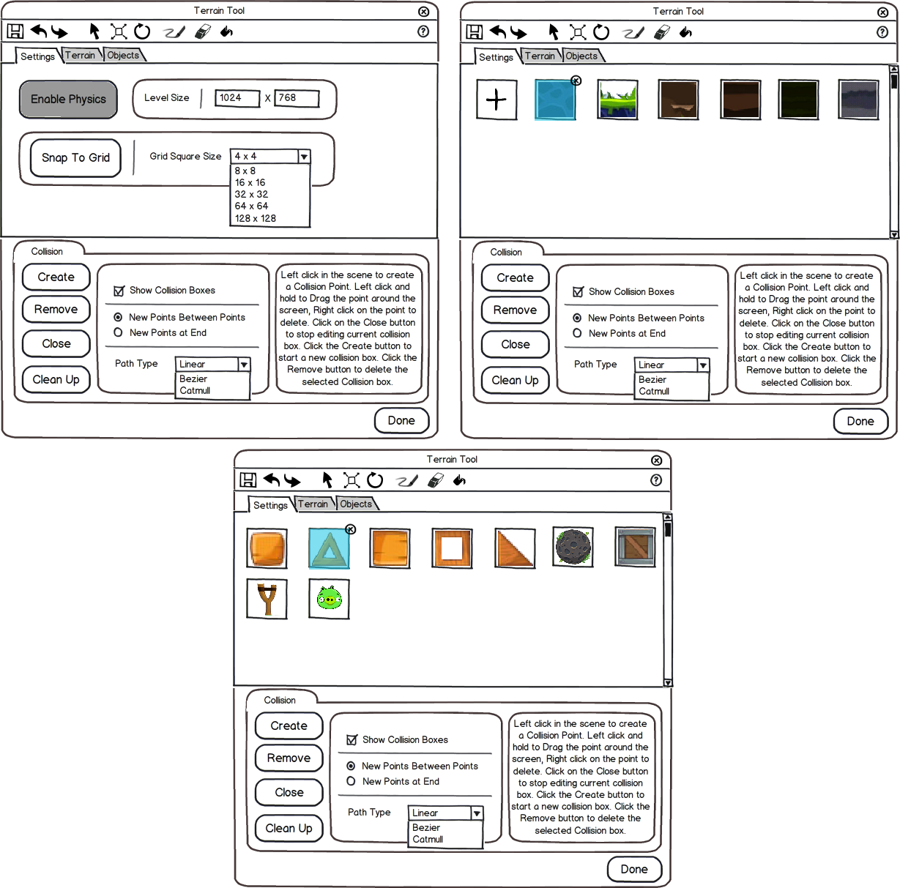

* The user will be able to drag and drop, paint, or fill a level with objects or terrain graphics
* All objects and terrain graphics will be able to select, delete, scale, or rotate
* Objects appear the size they were imported as from the Asset Library
* Users can add Terrain graphics by clicking on the Plus icon at the beginning of the list, this will open the Asset Library allowing the user to add new Sprites or Animations
* All Objects that are created with the Object tool will automatically get added to the Objects tab in the Terrain Tool
  + If a user clicks on the X at the top right of the objects icon will delete the object from the project
* The user will be able to directly create the collision areas on the level with tools similar to those in iT2D
  + All scenes will start with no collision box until the Create button is clicked, once clicked then a basic box will appear in the center of the screen
  + The user can do this multiple times to create additional collision boxes in the scene
  + The remaining tools will only be available after the user has selected a point on a collision box
  + The Remove button will delete the currently selected collision box from the scene
  + The Close button will stop all editing of that collision box and allow the user to select on other objects in the scene
  + The Clean Up button will remove any collision points that create a concave hull
  + The user can hide the collision boxes in the scene by unchecking the Show Collision Boxes
  + All collision points will have a number on them which will help the user on what the 2 radio options allow
    - When the radio New Points Between Points is selected, if the user left clicks in a space that is between any 2 points, a new collision point is created
    - When the radio New Points at End is selected, if the user left clicks anywhere, a new collision point will be created between the last 2 collision points in the sequence
  + Path Type drop down will allow the user to change the curvature of the path based on the selection of the drop down
    - Linear – The default path type. Creates sharp edges with no curves
    - Bezier – The edges of a Bezier path can have their curves individually edited. Simply drag the white handles next to each curve. Smaller curves will be sharper with a more direct movement, while wide curves will have a slower, smoother movement
    - Catmull – The edges of a Catmull path is determined dynamically by the placement of each node in the path
* The user can enable/disable physics by clicking the Enable Physics button to see how the objects are affected by physics
* The user is not restricted to the size of the screen for their level, the user may set a custom value to make the level any size
  + When the level is larger than the screen size
    - The player can click/touch and drag to move the camera around the screen to see everything
    - On iOS devices the player can use 2 fingers to zoom in or out with the camera
* The user can free style place objects or click the Snap to Grid button and enable the objects to snap to a grip that will become visible to the user
  + The size of the grid can be adjusted by using the drop down next to the Snap to Grid button

# Game References

## Angry Birds Games

* Angry Birds
* Angry Birds Seasons
* Angry Birds Rio
* Angry Birds Space

## Games Similar to Angry Birds

* Coco Loco
* iBlast Moki 2
* Crush the Castle
* Sieger